Issue 1 : Life Cycle Status : ‘Exception Use’ data is displayed as ‘UNKNOWN’ .

QA Query :

SELECT COALESCE(CONCAT('OT_LIFE_CYCLE_STATUS_C','~','PROCESSING_ACTIVITIES','~',upper(SRC.LIFE_CYCLE_STATUS)),'UNSPECIFIED') as Source_id,

LKP.row_id,SRC.LIFE_CYCLE_STATUS,LKP.dimension_name,Count(1) as CNT

FROM pandg_mdsdb.pg_mega_pgb_application_rita_final SRC

LEFT JOIN pandg_mdwdb.d_rita_application_c TRGT ON SRC.NAME=TRGT.row_id AND SRC.sourceinstance=TRGT.source_id

LEFT JOIN pandg_mdwdb.d_lov LKP ON

COALESCE(CONCAT('OT_LIFE_CYCLE_STATUS_C','~','PROCESSING_ACTIVITIES','~',upper(SRC.LIFE_CYCLE_STATUS)),'UNSPECIFIED')=LKP.row_id

AND SRC.sourceinstance=LKP.source_id

group by 1,2,3,4;

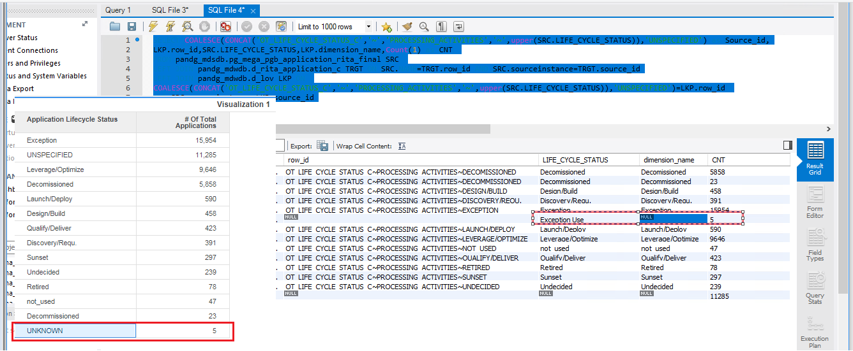

Fixed and Working fine :

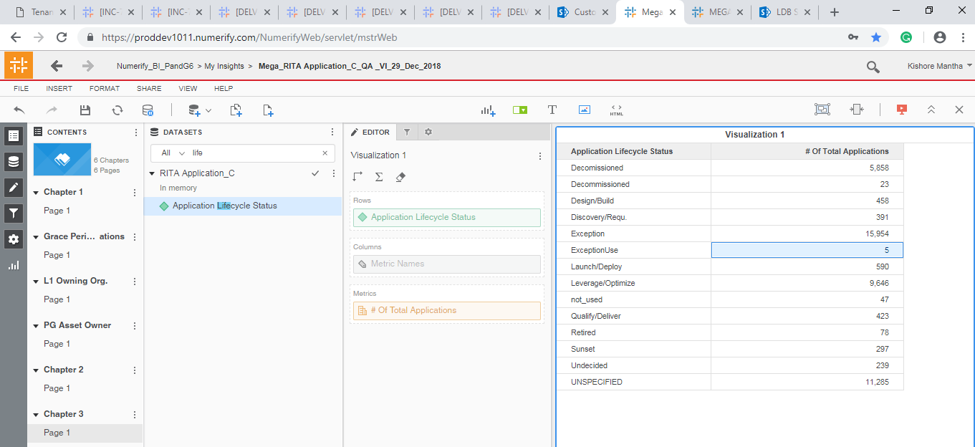

Issue 3: SRC.TOTAL_3RD_PARTY_WITH_ACCESS : ‘>=1,000 - <20,000’ is moved to UNKNOWN in the d_lov.

SELECT SRC.TOTAL_3RD_PARTY_WITH_ACCESS,LKP.dimension_name,

Count(1) as CNT

FROM pandg_mdsdb.pg_mega_pgb_application_rita_final SRC

LEFT JOIN pandg_mdwdb.d_rita_application_c TRGT ON SRC.NAME=TRGT.row_id AND SRC.sourceinstance=TRGT.source_id

LEFT JOIN pandg_mdwdb.d_lov LKP ON

COALESCE(CONCAT('OT_THIRD_PARTY_USERS_C','~','PROCESSING_ACTIVITIES','~',upper(SRC.TOTAL_3RD_PARTY_WITH_ACCESS)),'UNSPECIFIED')=LKP.row_id

AND SRC.sourceinstance=LKP.source_id

group by 1,2;

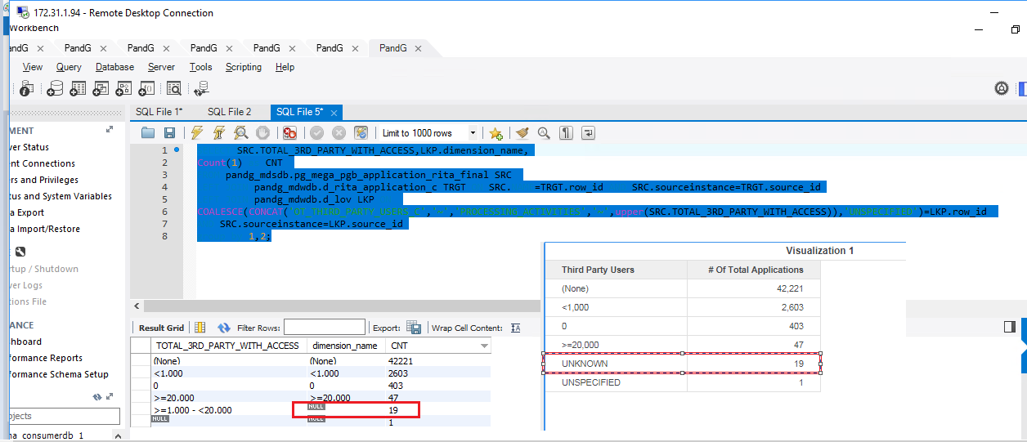

Fixed and Working fine :

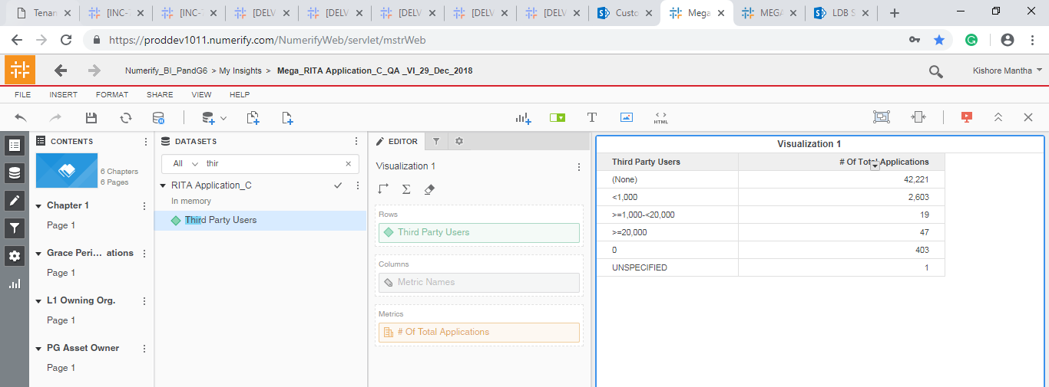

Issue 4: TOTAL_PG_PERSONNEL_WITH_ACCESS, ‘>=1,000 - <20,000’ is displayed as ‘UNKNOWN’

SELECT SRC.TOTAL_PG_PERSONNEL_WITH_ACCESS,LKP.dimension_name,

Count(1) as CNT

FROM pandg_mdsdb.pg_mega_pgb_application_rita_final SRC

LEFT JOIN pandg_mdwdb.d_rita_application_c TRGT ON SRC.NAME=TRGT.row_id AND SRC.sourceinstance=TRGT.source_id

LEFT JOIN pandg_mdwdb.d_lov LKP ON

COALESCE(CONCAT('OT_PG_USERS_C','~','PROCESSING_ACTIVITIES','~',upper(SRC.TOTAL_PG_PERSONNEL_WITH_ACCESS)),'UNSPECIFIED')=LKP.row_id

AND SRC.sourceinstance=LKP.source_id

group by 1,2;

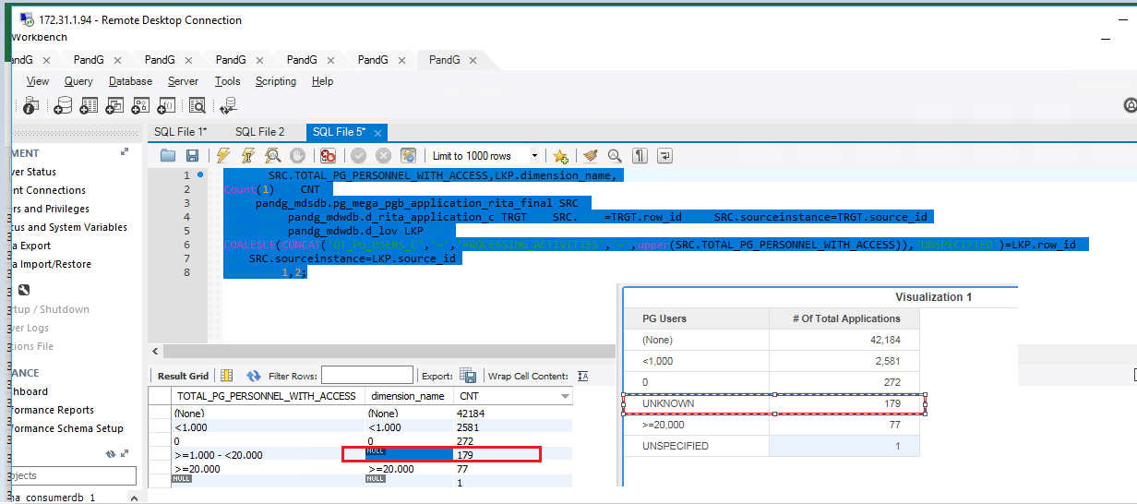

Fixed and Working fine:

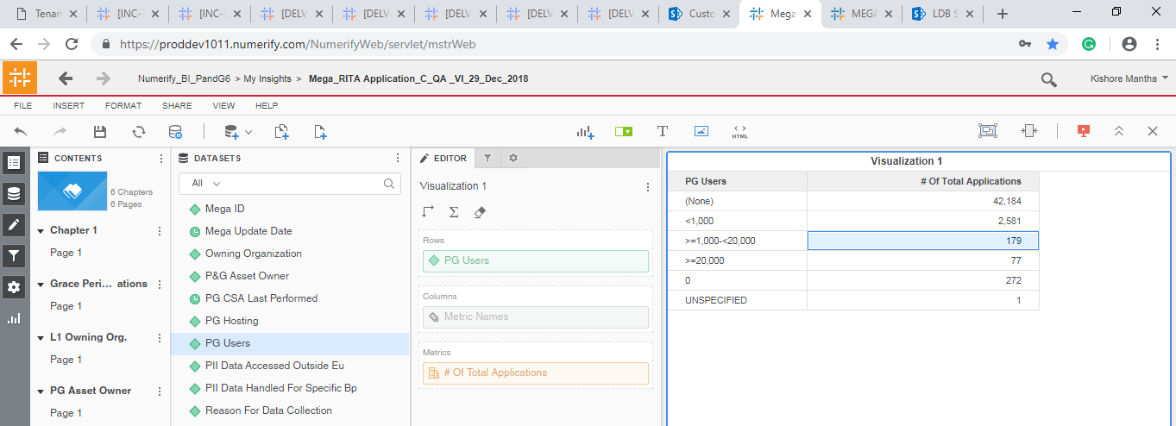

Fixed and Working fine :

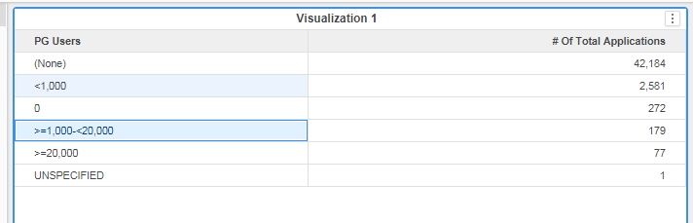

Issue 5:

Few L1 Owning Organizations are not displayed in Cube:

Ex: IT IT Development Organization and IT IT Innovation Organization

New Issues on 2-Jan-2018:

Issue 6:

Data mismatch between source and cube for certain ‘Retension_Span_Year’ :

SELECT

COALESCE(SRC.RETENTION_SPAN_YEARS,'UNSPECIFIED'),

Count(SRC.NAME) as CNT

FROM pandg_mdsdb.pg_mega_pgb_application_rita_final SRC

LEFT JOIN pandg_mdwdb.d_rita_application_c TRGT ON SRC.NAME=TRGT.row_id AND SRC.sourceinstance=TRGT.source_id

group by 1;

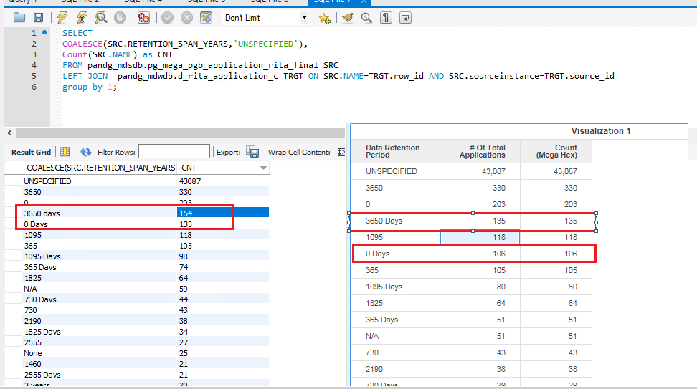

Issue 7: ‘Description’ field is displayed instead of ‘PG_CSA_Last_Performed’ Date :

SELECT SRC.SHORT_NAME,

COALESCE(date_format(substring(replace(SRC.PG_CSA_LAST_PEFORMED,' ',''),1,14),'%Y-%m-%d %h:%i:%s'),

''),TRGT.pg_csa_last_peformed,

Count(1) as CNT

FROM pandg_mdsdb.pg_mega_pgb_application_rita_final SRC

LEFT JOIN pandg_mdwdb.d_rita_application_c TRGT ON SRC.NAME=TRGT.row_id AND SRC.sourceinstance=TRGT.source_id

group by 1;

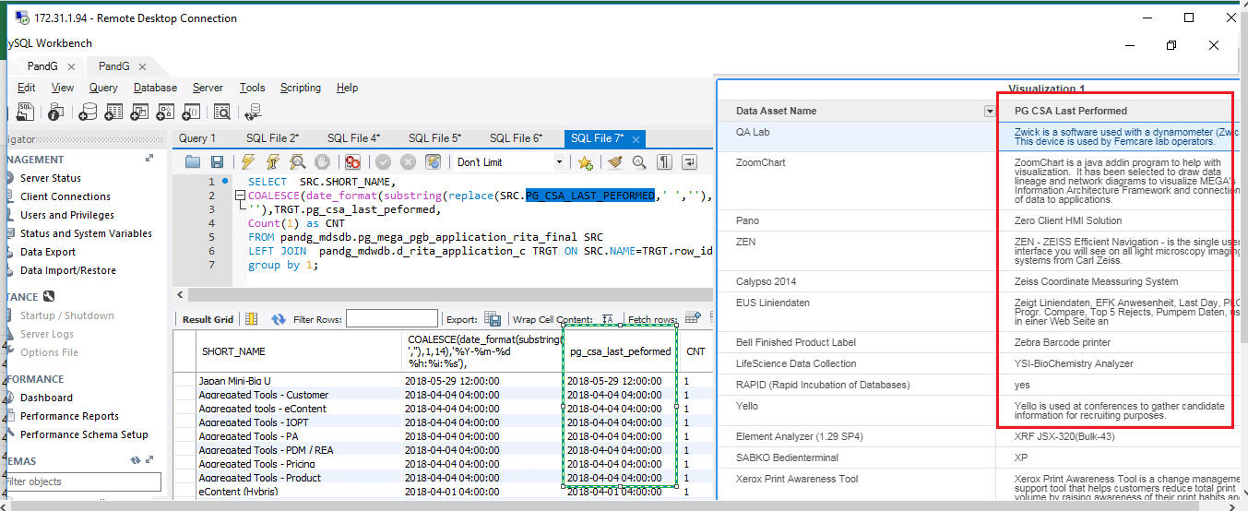

Issue 8: Metric values are not segregated based upon the ‘L1 Owning Organization’ (MSTR Issues).

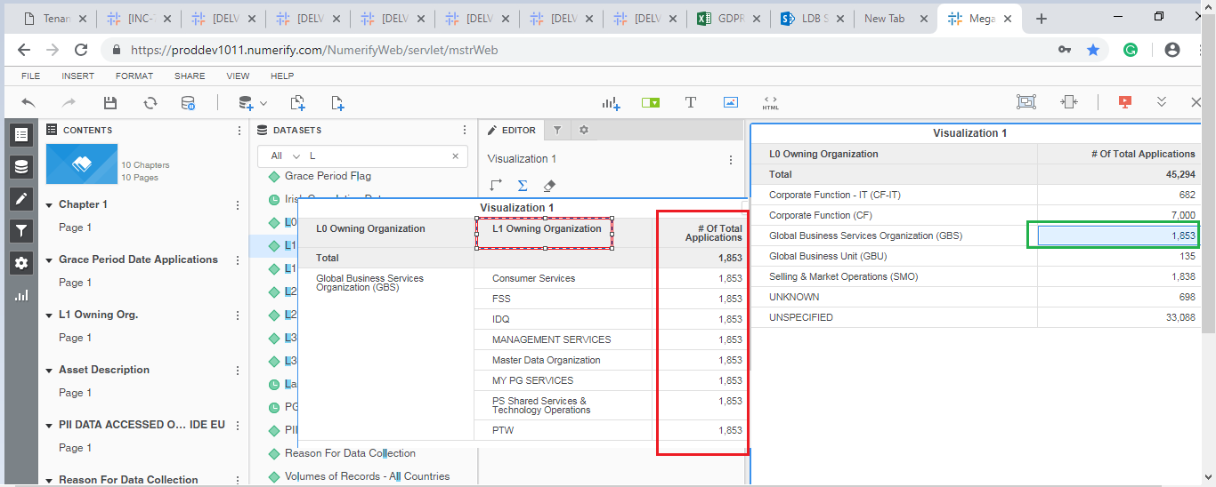

Issue 9: Data mismatch for the ‘Grace Period Start Date’ between Source and Cube.

SELECT CASE WHEN SRC.APPLICATION_NATURE IN ('Generic','XOApplication','NonDigital','Component')

AND SRC.LIFE_CYCLE_STATUS NOT IN ('Decomissioned','Exception Use','not_used','Undecided')

AND TRGT.gdpr_relevant_c_flag ='Y'

AND level1.LVL1_ORG_NAME IN

('Information Security','IT Consumer Solutions','IT Customer Solutions & Delivery','IT Data & Analytics Organization','IT IT Development Organization',

'IT IT Innovation Organization','IT Solutions','Consumer Services','FSS','IDQ','MANAGEMENT SERVICES','Master Data Organization','MY PG SERVICES','PS Shared Services & Technology Operations','PTW')THEN COALESCE(TRGT.grace_period_start_date,CONVERT_TZ(OD.lastupdated,'GMT','America/New_York'))

ELSE NULL END AS Source_Grace_Period_Start_Date,TRGT.grace_period_start_date,Count(distinct SRC.NAME) as Application_Count

FROM pandg_mdsdb.pg_mega_pgb_application_rita_final SRC

LEFT JOIN pandg_mdwdb.d_rita_application_c TRGT ON SRC.NAME=TRGT.row_id AND SRC.sourceinstance=TRGT.source_id

LEFT JOIN (select source_id,max(lastupdated) as lastupdated from pandg_mdwdb.o_data_freshness

group by source_id) OD ON TRGT.source_id=OD.source_id

LEFT JOIN

(SELECT a.app_hexid,a.sourceinstance,

CASE WHEN Count(1) <= 1 THEN MAX(COALESCE(a.responsible_org_unit_hexid,'UNSPECIFIED')) ELSE 'UNKNOWN' end as responsible_org_unit_hexid

FROM pandg_mdsdb.pg_mega_pgv_app_responsible_org_person_final a WHERE a.pg_development_org = 'Y' AND a.app_hexid IS NOT NULL

group by a.app_hexid,a.sourceinstance) SRC1 ON (SRC.NAME=SRC1.app_hexid AND SRC.sourceinstance=SRC1.sourceinstance )

LEFT JOIN pandg_mdsdb.pg_mega_pgv_org_itam_gbs_final level1

ON (SRC1.responsible_org_unit_hexid=level1.LVL1_ORG_HEX OR SRC1.responsible_org_unit_hexid=level1.LVL2_ORG_HEX

OR SRC1.responsible_org_unit_hexid=level1.LVL3_ORG_HEX)

AND SRC1.sourceinstance=level1.sourceinstance

group by 1,2;

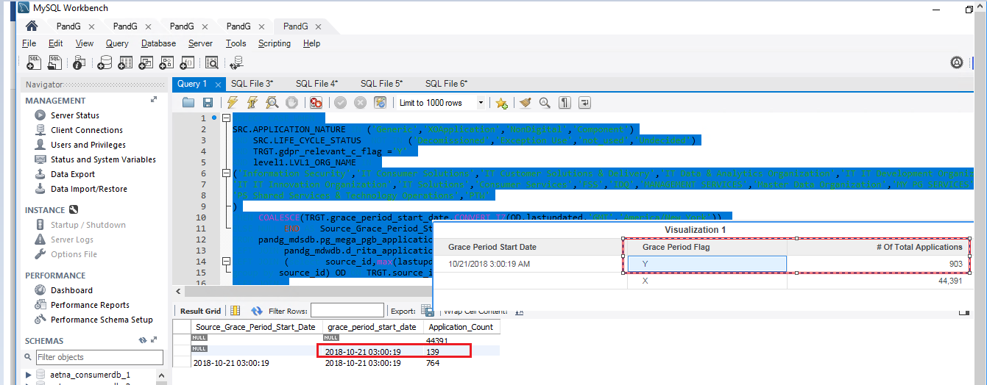

The ‘Grace Period Start Date’ is displayed as NULL even all the conditions are Met.

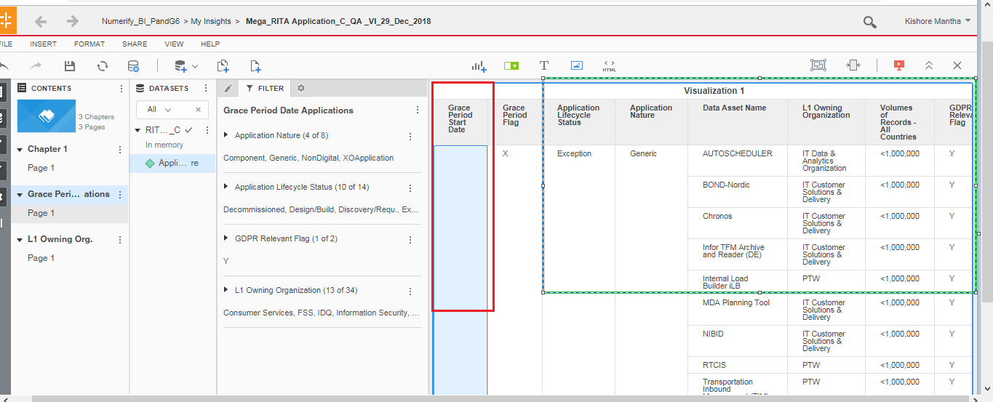

Issue 10: GDPR Relevant_Flag : is not working fine for 18 records :

SELECT SRC.SHORT_NAME,SRC1.KEYWORD_NAME,SRC.VOLUME_OF_RECORDS_EU,(CASE

WHEN SRC1.KEYWORD_NAME IN ('ITAM: GDPR - Relevance: No') THEN 'N'

WHEN SRC1.KEYWORD_NAME IN ('ITAM: GDPR - Relevance: Yes') THEN 'Y'

ELSE

IF ((SRC.VOLUME_OF_RECORDS_EU) = '0' OR (SRC.VOLUME_OF_RECORDS_EU) IS NULL OR ((SRC.VOLUME_OF_RECORDS_EU) = '' ),'N','Y') END ) AS Source_Relevant_Flag,TRGT.gdpr_relevant_c_flag

FROM pandg_mdsdb.pg_mega_pgb_application_rita_final SRC

LEFT JOIN pandg_mdsdb.pg_mega_pgb_app_keyword_final SRC1 ON SRC.NAME=SRC1.APP_HEXID AND SRC.sourceinstance=SRC1.sourceinstance

LEFT JOIN pandg_mdwdb.d_rita_application_c TRGT ON SRC.NAME=TRGT.row_id AND SRC.sourceinstance=TRGT.source_id

WHERE

(CASE

WHEN SRC1.KEYWORD_NAME IN ('ITAM: GDPR - Relevance: No') THEN 'N'

WHEN SRC1.KEYWORD_NAME IN ('ITAM: GDPR - Relevance: Yes') THEN 'Y'

ELSE

IF ((SRC.VOLUME_OF_RECORDS_EU) = '0' OR (SRC.VOLUME_OF_RECORDS_EU) IS NULL OR ((SRC.VOLUME_OF_RECORDS_EU) = '' ),'N','Y') END )

<>TRGT.gdpr_relevant_c_flag

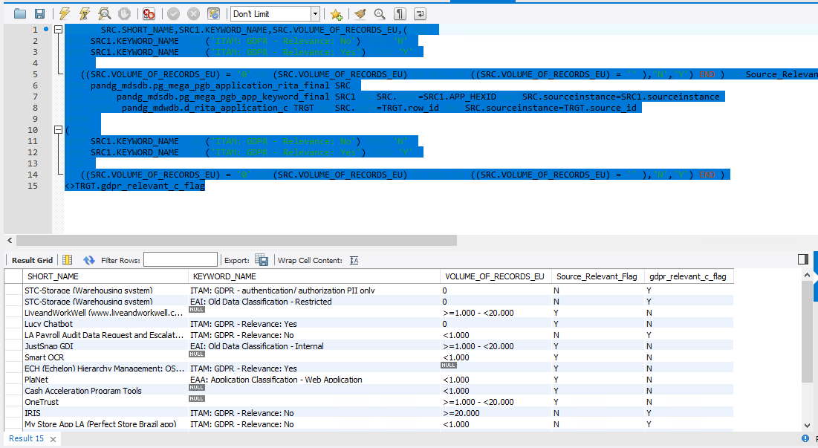

Issue 11: GDPR _override_Flag is not working fine :

SELECT SRC.NAME,SRC.SHORT_NAME,SRC1.KEYWORD_NAME,

(CASE WHEN SRC1.KEYWORD_NAME IN ('ITAM:GDPR -Grouping:1','ITAM:GDPR -Grouping:2','ITAM: GDPR - Grouping: 3','ITAM: GDPR - Grouping: 4') THEN 'Y'

ELSE 'N' END) AS Source,

TRGT.gdpr_flagoverrode_flag

FROM pandg_mdsdb.pg_mega_pgb_application_rita_final SRC

LEFT JOIN pandg_mdsdb.pg_mega_pgb_app_keyword_final SRC1 ON SRC.NAME=SRC1.APP_HEXID AND SRC.sourceinstance=SRC1.sourceinstance

LEFT JOIN pandg_mdwdb.d_rita_application_c TRGT ON SRC.NAME=TRGT.row_id AND SRC.sourceinstance=TRGT.source_id

WHERE SRC1.KEYWORD_NAME IN ('ITAM: GDPR - Grouping: 1','ITAM: GDPR - Grouping: 2','ITAM: GDPR - Grouping: 3','ITAM: GDPR - Grouping: 4');

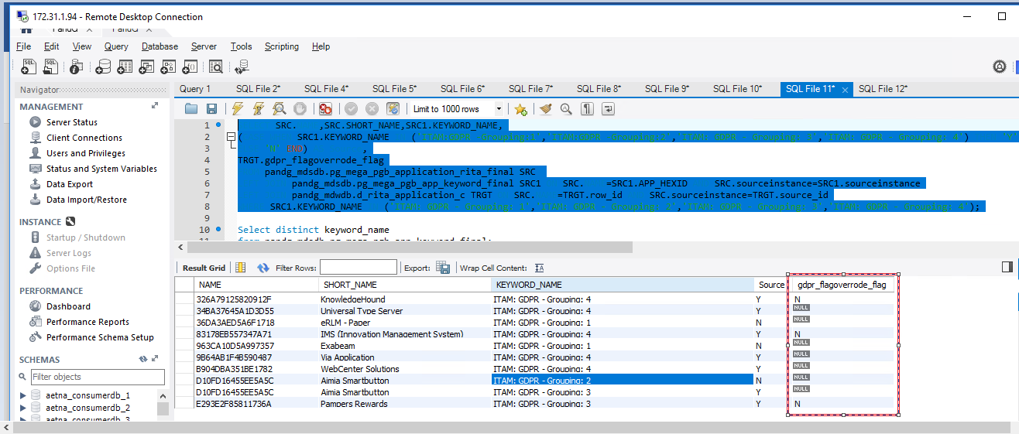

Issue 12: 5 Applications are marked as ‘Non-Sensitive’ even the Data Element Collected in then mentioned list :

Fixed and working fine.

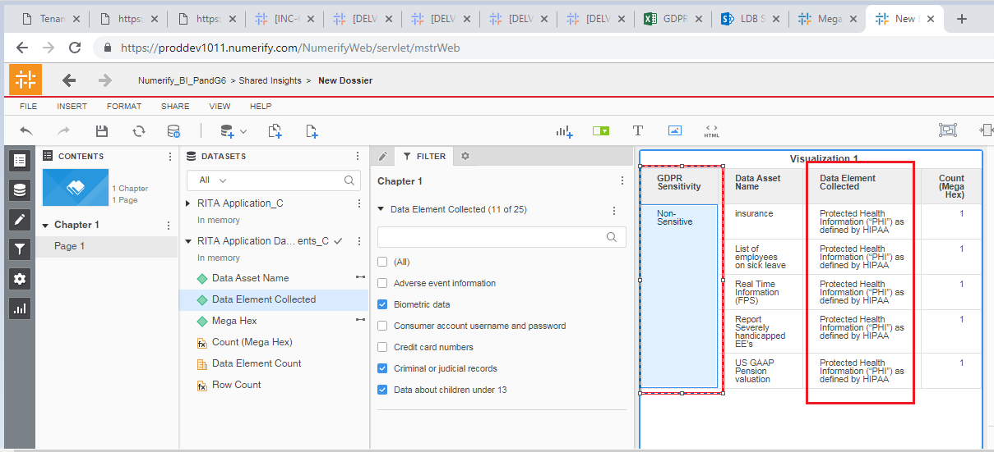

Issue 13: The Organization Lead is not displayed as expected.

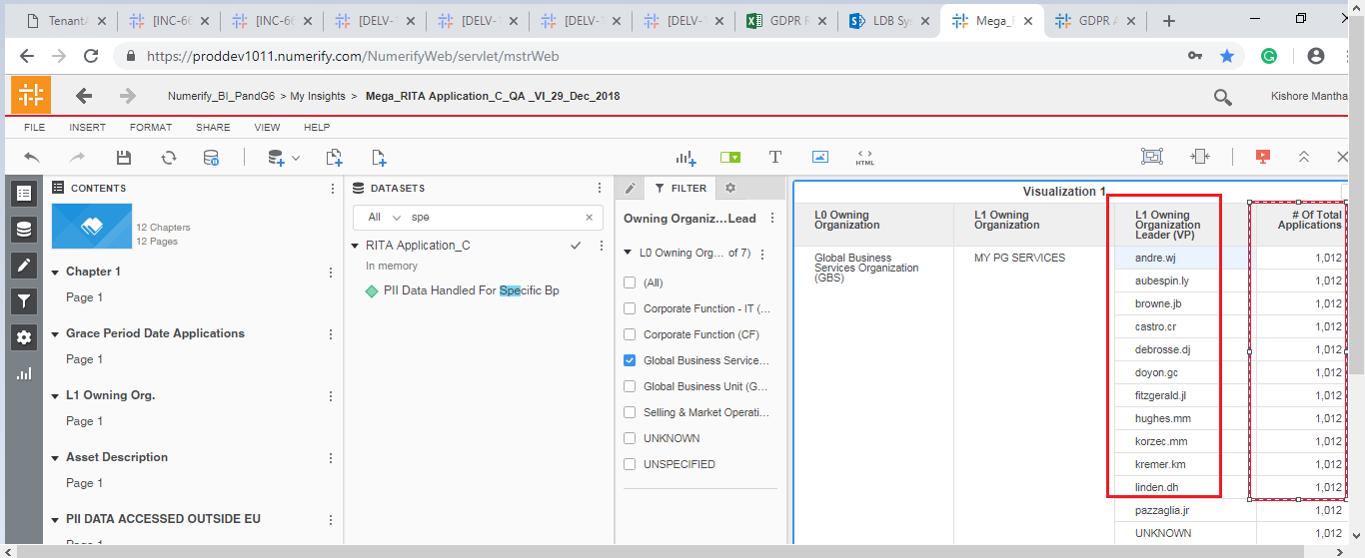

Issue 14:

SELECT distinct SRC1.ATTRIBUTE_NAME,(CASE WHEN SRC1.ATTRIBUTE_NAME ='Government ID, government-issued ID' THEN 'Y' ELSE 'N' END ),

TRGT.govt_id_flag

FROM pandg_mdsdb.pg_mega_pgb_application_rita_final SRC

LEFT JOIN pandg_mdsdb.pg_mega_pgv_application_data_model_final SRC1 ON SRC.NAME=SRC1.APP_HEX AND SRC.sourceinstance=SRC1.sourceinstance

LEFT JOIN pandg_mdwdb.d_rita_application_c TRGT ON SRC.NAME=TRGT.row_id AND SRC.sourceinstance=TRGT.source_id

Where SRC.SHORT_NAME='MS Tech. FSS AP P2P Pulse (DMS)';

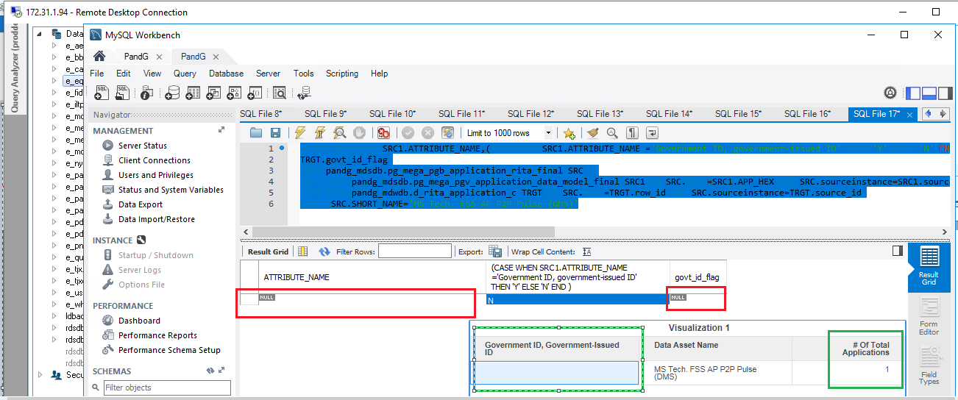

Issue 15: Only UNKNOWS are displayed in L1 Organization Leads:

SELECT distinct level1.LVL0_ORG_NAME,level1.LVL1_ORG_NAME,level1.LVL1_ORGLEAD_NAME,

Count(distinct SRC.NAME)

FROM pandg_mdsdb.pg_mega_pgb_application_rita_final SRC

LEFT JOIN

(SELECT a.app_hexid,a.sourceinstance,a.responsible_org_unit AS Owning_Organization,

CASE WHEN Count(distinct responsible_org_unit_hexid) <= 1 THEN MAX(COALESCE(a.responsible_org_unit_hexid,'UNSPECIFIED')) ELSE

'UNKNOWN' end as responsible_org_unit_hexid

FROM pandg_mdsdb.pg_mega_pgv_app_responsible_org_person_final a WHERE a.pg_development_org = 'Y'

group by a.app_hexid,a.sourceinstance

) SRC1 ON (SRC.NAME=SRC1.app_hexid AND SRC.sourceinstance=SRC1.sourceinstance )

LEFT JOIN pandg_mdsdb.pg_mega_pgv_org_itam_gbs_final level1

ON (SRC1.responsible_org_unit_hexid=level1.LVL1_ORG_HEX OR SRC1.responsible_org_unit_hexid=level1.LVL2_ORG_HEX

OR SRC1.responsible_org_unit_hexid=level1.LVL3_ORG_HEX)

AND SRC1.sourceinstance=level1.sourceinstance

WHERE level1.LVL0_ORG_NAME='Global Business Services Organization (GBS)'

AND SRC.cdctype <>'D'

group by 1,2,3;

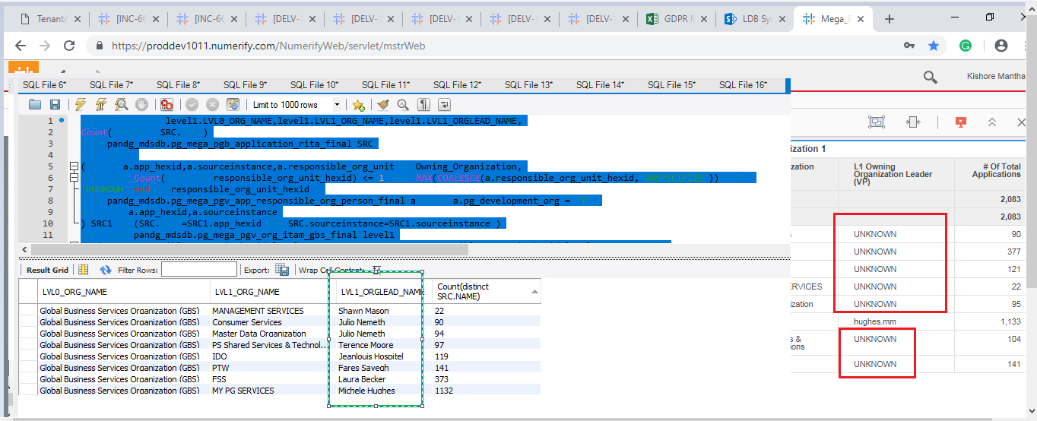

1. Count of the Application are not matched with Source :

Issue 16:on PII_Flag : Notice there is count mismatch between MDS and MDWD (mysql), there are 69 records in source with PHI attribute name, but in cube no ‘Y’ is displayed.

SELECT (CASE WHEN SRC1.ATTRIBUTE_NAME ='Protected Health Information (“PHI”) as defined by HIPAA' THEN 'Y' ELSE 'N' END ) AS Source_flag,TRGT.phi_flag,

Count(distinct SRC.NAME) as CNT

FROM pandg_mdsdb.pg_mega_pgb_application_rita_final SRC

LEFT JOIN pandg_mdsdb.pg_mega_pgv_application_data_model_final SRC1 ON SRC.NAME=SRC1.APP_HEX AND SRC.sourceinstance=SRC1.sourceinstance

LEFT JOIN pandg_mdwdb.d_rita_application_c TRGT ON SRC.NAME=TRGT.row_id AND SRC.sourceinstance=TRGT.source_id

WHERE SRC.cdctype<>'D'

group by 1,2;

Select b.phi_flag,count(1) as CNT

FROM pandg_mdwdb.f_rita_application_c a

JOIN pandg_mdwdb.d_rita_application_c b ON a.rita_application_c_key=b.row_key

WHERE a.soft_deleted_flag='N'

group by 1;

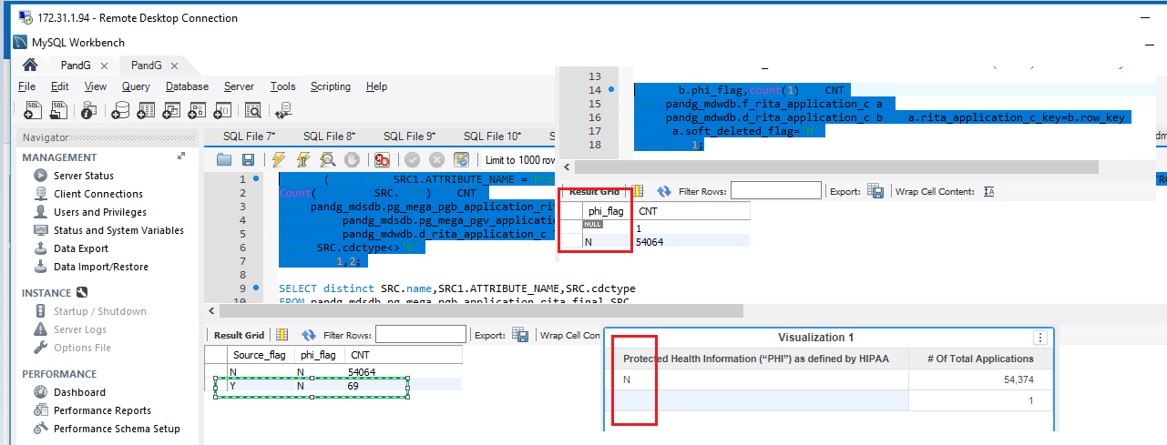

Fixed and Working fine :

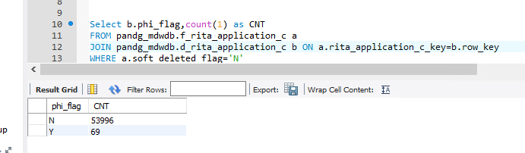

Issue 17:

GDPR Sensitivity is failed for one records :

SELECT a.NAME,COALESCE(X.gdpr_sensitivity,'UNSPECIFIED'),TRGT.gdpr_sensitivity

FROM pandg_mdsdb.pg_mega_pgb_application_rita_final a

LEFT JOIN

(

select app_hex, sourceinstance,MAX(gdpr_sensitivity) as gdpr_sensitivity from(

select app_hex, sourceinstance, ATTRIBUTE_NAME ,(CASE WHEN ATTRIBUTE_NAME in

('Biometric data'

,'Genetic data'

,'Sex life, sexual orientation questions'

,'Data about children under 13'

,'Criminal or judicial records'

,'Precise geo location data'

,'Racial or ethnic origin'

,'Political opinions, political party affiliation'

,'Trade union membership'

,'Protected Health Information (“PHI”) as defined by HIPAA'

,'Other health or medical data') THEN 'Sensitive' ELSE 'Non-Sensitive' END)

AS gdpr_sensitivity

FROM pandg_mdsdb.pg_mega_pgv_application_data_model_final)Y

GROUP BY 1,2)X ON a.NAME=X.app_hex AND a.sourceinstance=X.sourceinstance AND a.cdctype <>'D'

LEFT JOIN pandg_mdwdb.d_rita_application_c TRGT ON a.NAME=TRGT.row_id AND a.sourceinstance=TRGT.source_id

WHERE COALESCE(X.gdpr_sensitivity,'UNSPECIFIED')<>TRGT.gdpr_sensitivity

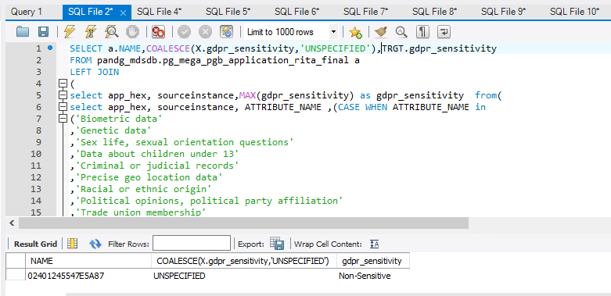

Observations 1:

Not all the Level 1 Organizations are not displayed in Cube :

Example : Below Level1 Organizations are not coming in cube.

GBU-Baby Feminine & Family

GBU-Beauty

GBU-Global P&G

GBU-Health and Grooming

IT IT Development Organization

IT IT Innovation Organization

CF-Gen Admin

Queries :

SELECT Count(distinct level1.LVL1_ORG_NAME)

FROM png_mdsdb.pg_mega_pgb_application_rita_final SRC

LEFT JOIN

(SELECT a.app_hexid,a.sourceinstance,a.responsible_org_unit AS Owning_Organization,

CASE WHEN Count(distinct responsible_org_unit_hexid) <= 1 THEN MAX(COALESCE(a.responsible_org_unit_hexid,'UNSPECIFIED')) ELSE

'UNKNOWN' end as responsible_org_unit_hexid

FROM png_mdsdb.pg_mega_pgv_app_responsible_org_person_final a WHERE a.pg_development_org = 'Y'

group by a.app_hexid,a.sourceinstance

) SRC1 ON (SRC.NAME=SRC1.app_hexid AND SRC.sourceinstance=SRC1.sourceinstance )

LEFT JOIN png_mdsdb.pg_mega_pgv_org_itam_gbs_final level1

ON (SRC1.responsible_org_unit_hexid=level1.LVL1_ORG_HEX

AND SRC1.sourceinstance=level1.sourceinstance );

SELECT Count(distinct a.LVL1_ORG_NAME)

FROM png_mdsdb.pg_mega_pgv_org_itam_gbs_final a;

